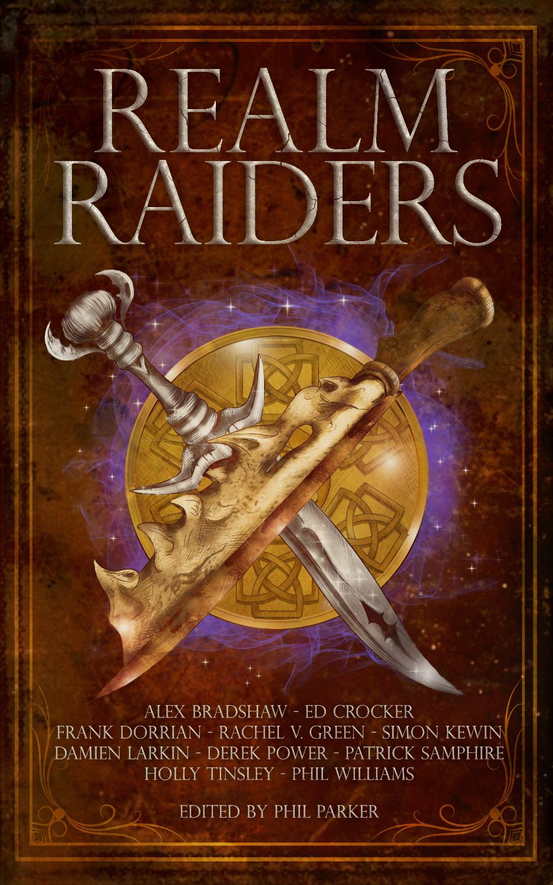
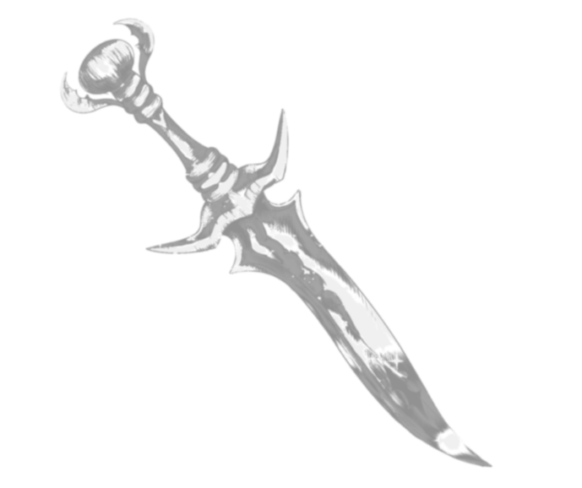
Chapter 7
In which our heroes explore the meaning of tooth, blood and claw
by Alex S. Bradshaw
The team tumbled through the portal in a knot of limbs and curses down the ancient wooden steps and onto the soft soil.
Slowly, the three of them untangled themselves from each other and moved to stand at the centre of the jungle clearing.
‘What the fuck was that?’ Greton moaned, rolling his neck before pointing at the top of the stairs to the empty platform. ‘Isn’t our Pathfinder supposed to keep the portals safe and easy to use? Thank fuck we only fell down the stairs. What if that had happened on the portal to Mycelia? You stumble there and you’re falling off a fucking cliff.’
‘I thought you were supposed to be tough,’ Hoji said with a smirk, then hissed through his teeth as he shook his leg. ‘You fall down.... four stairs and you’re already bitching?’
‘Shut up, both of you,’ Rhen snapped. She finished checking over her pack then stood and brushed the loose dirt from her coat. ‘It’s Vouring. He’s already infecting the spaces between worlds. It will only get worse so let’s get a fucking move on.’
Greton gritted his teeth. There was no point arguing with Rhen. As Pathfinder she was there to get the job done, everything else was a distraction. Greton sat up, put his hand on Hoji’s shoulder, and pushed down on the other man to get himself up. Hoji cursed as Greton shoved him deeper into the mud but Greton just grinned.
‘What’s the deal, then, boss?’ Greton asked. ‘We had to get out so quick no one told Hoji.’
‘No one told you either, shitstain.’
Rhen sliced a hand through the air to cut off their bickering. They fell silent.
Around them, the jungle hummed back to life. Insects buzzed around them, birds sung in the distance, and something hopped away from them through the undergrowth.
Greton glanced at the nine gargantuan trees lining the clearing. They had been torn down hundreds of years ago, but they looked as vibrant as the day they had been felled. Only the statues carved into the redwood-sized trunks gave any indication to their age. The same figure was carved into each tree though each statue differed to show some particular aspect of Vouring. This one had Vouring with the open jaws of a wolf in place of a human mouth. That one he was wrapped in leathery wings with two clawed fingers overlapping like some bestial clasp. The statues’ once-smooth and bright heartwood was now grimy and mould-slicked and peppered with deep cuts. Each cut bled bright red sap that smoked in the dim light.
Greton shuddered.
‘Come on, boss, this place gives me the creeps.’ Greton ignored Hoji’s snickering. ‘Which way?’
Rhen didn’t pull her gaze from the bleeding trees as she said, ‘Fuck knows. We’re looking for some kind of ritual site. My source believes the relic will be hidden beneath an altar. Probably buried. The Azrani aren’t likely to leave it lying around when it’s worth six thousand Veks.”
Hoji nodded, spat on the ground, and stepped up to join the others. ‘Don’t the bats have like a hundred different places they do rituals?’
Rhen shot Hoji a look. ‘Don’t call them that, asshole. We may be here to rob them, but we can still show a little respect.’
Greton grinned but kept his silence.
Rhen took out a battered map from her coat and glanced it over. ‘The Azrani do have a lot of temples and places dedicated to various rituals, but I have a feeling we need to visit the one place they won’t go.’
‘Ah fuck.’ Greton’s shoulders slumped. He’d been to the jungles of Azra often enough that he knew how to handle himself, but he’d never been to the oldest temple. He shot a glance at Hoji and the man looked just as apprehensive as he did. ‘Rhen, you don’t mean...’
‘We’re headed to the Temple of Nine.’ Rhen shoved the map back in her coat pocket. ‘No arguments. Let’s go.’
Rhen turned away from the well-trodden road that would have taken the team to one of the Azrani cities and marched into the jungle. Greton and Hoji glanced at each other. For once, neither of them sneered, they simply shared a look of determination laced with fear.

*

Vines, bushes, and half-fallen trees quickly overwhelmed their chosen path leaving the team to duck under branches and cut through leaves to make their way forward. Rhen kept up the pace and it was not long before Greton sweated through his linen shirt. From the look of Hoji’s shining forehead he was the same.
‘Quiet.’
Rhen hushed Greton. He had been grumbling about the heat and the leaves that kept whipping into his face but fell silent as soon as Rhen stopped.
He couldn’t hear anything over the buzz and hum of the jungle but he trusted Rhen. Slowly, he shifted his machete into his left hand and started summoning flame into his right.
‘Don’t,’ Rhen hissed. ‘The Azrani won’t let us use fire. Put it out.’
Greton gritted his teeth against a complaint but did as he was told. He could feel Hoji’s joy behind him.
‘We’re nearly there,’ Rhen said and ducked under the fallen tree in front of them. ‘Quiet as you can. There’s something nearby.’
Greton had fought his share of monsters on Azra and he was not keen to do it again. He tightened his grip on his machete, back in his right hand, and followed as quietly as he could.
As they neared the Temple of Nine, Greton spotted some Azrani dwellings. The bat-like people built their homes high above the ground, setting timber frame buildings directly into the trunks of the enormous trees and often draping them with bright cloth that caught in the breeze and gave their settlements the feeling they were just as alive as the forest they lived in.
Usually, Greton found the sight beautiful and humbling, but not these.
These homes had been long abandoned. The planks were rotten, and half fallen away and the once-beautiful drapery had caught some of the floor and walls that now hung loose like a rotten carcass caught in the branches.
He gripped his machete tighter and hurried on to catch up with Rhen and Hoji.
‘How much further?’ Greton whispered.
Rhen frowned at him but nodded at the way ahead. ‘Over this rise then the temple’s in the valley beyond.’
She gestured for them to go ahead and pressed a finger to her lips. The hairs on the back of Greton’s neck stood on end as the forest fell silent around them. For a long moment all Greton could hear was the thumping of his own heart, his ragged breathing, and the creak of the dead houses behind them.
The crack of a branch in the distance.
They froze in place.
Behind him, Greton heard the hiss of Rhen’s swords leaving their scabbards. In front, Hoji pulled his warhammer from his back. For his part, Greton gripped his machete tight and summoned a gauntlet of stone to cover his clenched fist and forearm.
The forest was drenched in the silent tension of a predator on the hunt. With every second, Greton’s heart beat faster. Leather creaked as he gripped his machete even tighter and the low rumble of rock as he thickened his stone armour.
And the silence went on. For a minute. Then two.
Greton grunted and glanced back at Rhen. ‘Must have been--’
Something smashed into Greton and threw him into the undergrowth. He screamed but his voice was drowned out by snapping branches and the high-pitched hiss from whatever had attacked him.
He wrenched his stone-clad arm from underneath him as huge reptilian jaws lunged down. The thing’s teeth clamped down on his summoned armour. Greton groaned as his ribs creaked under the beast’s massive weight.
Then it screamed and was gone.
Hoji roared, raising his warhammer for another strike, then leapt after the creature.
Greton clambered to his feet. He flexed his fist as he pushed molten spikes from his stone gauntlet and stumbled through the undergrowth after Hoji.
It was a damn yitxal. The hulking thing was somewhere between a gorilla and a komodo dragon. Six feet at the shoulder. Its arms and back bulged with muscle and its long reptilian maw glistened with razor sharp teeth. Greton fucking hated yixtal. It pushed itself upright with arms as thick as Greton’s waist then threw itself at Hoji.
Rhen lunged in first, carving a deep line into the scaly flesh with her sword. The yitxal hissed as it charged and twisted to try and grab Rhen in its long, taloned fingers.
Its eyes were wild. Saliva whipped around its jaws. Hundreds of cuts along its back glistened red smoke and trailed burning sap.
The yixtal smashed Rhen out of its way before Greton could take another step, then the thing launched itself at Hoji.
The big man swung his hammer to meet it. The crunch echoed around the jungle as it smashed into the yixtal’s arm. The thing screamed in pain and snapped its jaw at Hoji who had to stumble to avoid the glittering teeth.
Greton charged in, a wavering war cry on his lips, and swung his machete. It bit into the yixtal’s other arm, barely breaking the skin. Greton cursed as the yixtal turned to face him.
The smell of burning sap and searing flesh enveloped him.
Greton coughed.
The yixtal’s jaws snapped at his face.
Greton swung his stone fist.
The molten spikes bit and burned into flesh. Stone crunched against bone.
The yixtal squealed and thrashed its body to pull itself free. The strength of the beast yanked Greton off his feet and for a moment he was weightless. Behind the writhing yixtal he saw Rhen and Hoji rushing back into the fight.
Greton stabbed his machete into the beast again and again, not able to tell if he hit anything vital and only knowing that with every thrust he was covered in more hot blood and burning sap.
He slammed into the ground with the full weight of the yixtal on top of him. The monster still writhed and screamed and managed to get its face free of his spiked stone gauntlet.
It spun, throwing Rhen and Hoji back, then with a pain-laced hiss whipped back around to Greton.
One enormous arm, dripping with blood, slammed onto Greton’s right arm.
He screamed.
Blood dripped onto Greton’s chest. Sap hung from the thing’s wounds like tentacles ready to pull him into an embrace. The yixtal’s wide eyes found his and its teeth came for him.
Hoji’s hammer crunched into the head of the beast, knocking it aside and into a nearby tree. Its sap-tendrils writhed and spasmed and then it was still.
‘Thanks,’ Greton said through gritted teeth.
Hoji grunted but before he could say anything another lizard-beast screamed somewhere in the jungle.
Greton stumbled to his feet. He tried to keep hold of his machete but it slipped from his grasp. He gritted his teeth and summoned more stone to cover his left arm and stood in front of Hoji. The ground shook as the lizard-beast charged, unseen. Then it exploded through the undergrowth, barrelling towards them. Greton fired off a couple of flint slivers through the jungle and was rewarded with a screech of pain.
But still the beast kept coming.
Greton swore and readied himself to summon an earthen barrier.
Something whistled past Greton’s head. Then again and again.
Darts.
The thunderous steps slowed and lost their rhythm but they did not stop.
As the reptilian gorilla leapt at them, its body writhing with smoking sap, Greton raised a wall of earth between them and it. The beast smashed into the wall, shaking loose a rain of bugs and worms onto Greton. He spat and cursed and shot a look at Hoji.
The big man had his hammer in a white-knuckle grip. He nodded at Greton and tensed.
Greton dropped the wall of earth and leapt out the way at the same time Hoji charged forward.
The monster managed to raise one meaty arm to block Hoji’s first swing, but it was too slow to block the second.
As the yixtal tried to gather itself for another attack more darts whistled past Greton to sink into its neck. The thing’s eyes flickered. It gave one last pathetic snarl then fell to the ground, lifeless.
‘What’s up with it?’ Hoji said, nudging the poisoned yixtal with his boot though he was careful to avoid any burning tendrils of sap.
Greton shrugged, then winced as it sent pain shivering through his ruined arm. ‘How the fuck should I know?’
He looked around as Rhen came into view through the trees. She wrenched a leaf off a nearby bush and used it to clean her swords. Behind her Greton spotted another dead yixtal.
‘Any ideas, boss?’ Hoji asked.
Three heavy thumps shook the ground before Rhen could answer.
Greton spun to face their new enemy but when he saw what it was, he let the cracked stone shield crumble from his good arm.
Azrani.
Greton suppressed a shiver as he looked at them. Their cities always instilled a sense of awe in him, but something about the people themselves set the primal part of his brain on edge. Maybe it was because there was nothing like them back on his home world so his brain didn’t know what to do with them.
The Azrani had wings of stretched skin like bats, that sprouted from their shoulders: they held them high as they walked towards the team on cloven hoofs. It was the arms, Greton decided, that creeped him out the most. As well as the huge wings at their backs the Azrani all had arms on the front of their chest like those of a praying mantis and right now the two larger Azrani clutched blowpipes, the smaller leading the way held some kind of sceptre or wand. Greton had never been able to read their expressions, as they had porcine snouts with tusks like warthogs, so he had no idea if he should get ready for another fight.
The smallest Azrani, still as big as Greton himself, ignored the group and knelt by the closest yixtal corpse.
‘What have you done?’ They demanded as they poked at the corpse with one of their mantis-arms. Every word was clipped as it was forced through a mouth not made for human language. ‘This creature has been corrupted by Vouring. This has not been seen since the days of the Edain. Yet, the world shivers, you arrive, and the poisoned monsters of legend live once more.’
Rhen took a step forward but the Azrani fanned out its wings in warning. She stopped and held up her hands.
‘Peace. This has nothing to do with us. We’re here to worship the nine, nothing more.”
Greton edged up behind Rhen, ready to back her up if needed. As always, the ease with which she lied was both impressive and disturbing.
The two big Azrani shifted behind the smaller one, clearly the leader. They spoke amongst themselves, voices a mix of sharp grunts and inward whistles, until one of the larger Azrani flew off and the small leader turned back to them.
‘Explain,’ it snapped.
Rhen’s eyebrows tipped towards her hairline. “The yixtals are a symptom of Vouring’s stirring. Every Realm is experiencing something like it: a weakening of the bonds that hold back his evil. We came to Azra to pray to the nine for salvation. They are our only hope.”
She tipped her head in a pious gesture, which might have been more believable if Yixtal blood wasn’t smeared across her cheek.
‘Prayer is needed,’ the Azrani repeated, his black eyes taking in every detail of Rhen’s performance. After a moment’s hesitation, it glanced back at its remaining bodyguard and said something in their strange language. The bigger Azrani stepped forward and gave a terse reply, one of his mantis-arms cutting down in denial.
Greton tensed, clenching a fist, but the small Azrani shouted the big one down before turning back to the group. The warrior Azrani rumbled but made no further objections.
‘I wish you well,’ the small Azrani said. ‘We will withdraw and leave you to your pilgrimage. Such worship is needed in these dark days. But tread carefully in our Realm, strangers. Your journey will not be without peril.’
‘Fantastic,’ Greton grumbled, plastering what he hoped was a warm smile on his face. ‘Can you point us in the right direction for the temple of the nine, bat?’
The big Azrani took a threatening step towards him, Greton flinched, instantly regretting the slip of the tongue. But the small Azrani flexed a wing, putting it between Greton and its bodyguard to keep them apart.
‘North,’ the Azrani said simply, before turning to leave.
Rhen took a step forward. ‘We would be grateful if you …’
The small Azrani coughed something in its strange language and the two creatures leapt into the air and flew off into the jungle’s depths.
Rhen shot Greton a venomous look.
‘What?’ he said. ‘I was just trying to get us there quicker.’
‘I told you not to call them that, dickhead,’ she hissed. ‘Come on. Let’s get to the temple.’
Greton frowned as Rhen stormed off through the jungle. Hoji clomped past him, cuffing him on the back of the head as he went.
‘Oh, fuck off, piss-brains,’ Greton shouted.
He flexed his injured arm and glanced at the still-smoking yixtal bodies before hurrying after the rest of his team. Greton hoped that the Temple of Nine was as dead as those ancient priest-kings.

*

They fought their way through the jungle. Greton grumbled to himself about the bugs and the squelching mud that somehow found its way into his boots until Rhen told him to shut the fuck up. Greton sighed. Rhen had said this was a quick job. One part of a larger operation. They can get in, get out, get paid. Then he would find a nice-looking girl at the bar and buy her however many drinks it took for him to look pretty.
He slipped on wet med, knocking his head on a low branch.
Hoji chuckled and Greton summoned a pebble into his palm before chucking it at Hoji’s head.
‘You fucker,’ Hoji growled and turned, one hand going to his hammer.
‘Stop it before I stick you both,’ Rhen snapped from the top of the rise ahead of them. ‘We’re here.’
Hoji and Greton joined her and looked out over the jungle beyond.
In the centre of the valley was a ruin. A circle of crumbling stone that had collapsed on the far side, leaving its walls to be overrun with vines and trees. Whatever statues had lined the entrance and flat roof of the temple had long since fallen to ruin but they could see some central plaza within it draped in shadows.
‘Come on,’ Rhen said and moved on without waiting for a response.
They struggled on through the jungle for an hour before they could make out the ancient walls ahead of them. Roots and time had destroyed much of the carvings on the outer walls, leaving only a hint of humanoid figures, but the gates were still standing.
Two enormous Azrani statues stood guard with their wings unfurled and now draped with vines like the smoking sap that had infested the yixtal. The doorway between them was perhaps ten feet tall and the massive wooden doors, reinforced with tarnished bronze bands, stood ajar.
Rhen led them into the shadows of the statues, and they stared through the gap in the doors and into the crumbling stone passageway ahead.
‘Greton, light the torches,’ Rhen’s voice cut through the sudden silence of the jungle.
Greton shivered. Between the silence and the blackness beyond the doors, he felt a cold terror begin to harden in his gut. He glanced over at Hoji. The moron’s face was covered in worry and Greton would be damned if he let that hammer-wielding idiot get the better of him.
Greton took a breath and stepped up to the doors. Nine torches, rusted into their sconces, lined the walls on either side of the doors. Greton summoned a flame into his right hand and lit as many torches as he could reach, only four each side and he scowled when Hoji snickered at him as he stretched to light the higher ones. He gripped one of the lower torches and built up the flame in his hand, trying to burn away the rust and rip the torch free. He did not trust the darkness within the temple. They had to take as much light as they could.
‘Leave it,’ Rhen said after a moment of Greton struggling with the rusted torch. ‘We don’t have time for that. We need to get the relic and get out. Let’s go.’
They marched across the threshold of the Temple of Nine and into the darkness beyond.

